**KEV FAIB COV TSHUAJ TIV THAIV KAB MOB COVID-19**



*Lub sijhawm no yog mus raws cov kev pom zoo tshuaj tiv thaiv kab mob thiab kev muaj txaus siv. Txhua lub sijhawm raug kwv yees thiab tuaj yeem hloov pauv

Cov tshuaj tiv thaiv kab mob COVID-19 yuav muab faib ua ntu zus. Daim duab no qhia txog cov tshuaj tiv thaiv kab mob thiab Cia siab tias yuav tau npaj txhij.

**Lub Sijhawm Zoo Txhawm Rau Kev Nthuav Tawm**

**To track the COVID-19 vaccines currently in development, visit:** <https://www.nytimes.com/interactive/2020/science/coronavirus-vaccine-tracker.html>

<https://www.who.int/publications/m/item/draft-landscape-of-covid-19-candidate-vaccines>

**For additional information on strategies of vaccine distribution:**

<https://www.hhs.gov/sites/default/files/strategy-for-distributing-covid-19-vaccine.pdf>

<https://www.cdc.gov/vaccines/imz-managers/downloads/COVID-19-Vaccination-Program-Interim_Playbook.pdf>

<https://media.defense.gov/2020/Sep/16/2002498504/-1/-1/1/OWS-VACCINE-DISTRIBUTION-GRAPHIC.pdf>

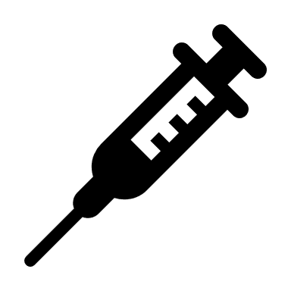****

**Qhov tseeb ntawm ntau qov kev faib**

Thawj cov tshuaj tiv thaiv kab mob yuav muab los ntawm kev txhaj tshuaj. Lawv yuav tsum raug txhaj ob koob uas sib nrug los ntawm ntau lub lis tiam.

Cov tshuaj tiv thaiv kab mob no muaj pub dawb los yog tsis muaj nyiaj tuav pov hwm.

**Kev tsos cai siv thaum uas muaj xwm txheej ceev**

Thawj cov tshuaj tiv thaiv kab mob raug pom zoo nyob rau hauv kev tso cai siv thaum uas muaj xwm txheej ceev.

Qhov kev tso cai xav kom txhaj tshuaj tiv thaiv kab mob txhawm rau kom muaj pov thawj thiab siv tau.

**Cov menyuam yaus thiab cov poj niam cev xeeb tub**

Thawj cov tshuaj tiv thaiv kab mob tsis tas kev pom zoo siv rau cov menyuam yaus thiab cov neeg cev xeeb tub lossis xeeb menyuam.

Yuav tsum muaj ntaub ntawv ntxiv txog ntawm cov tshuaj tiv thaiv kab mob muaj kev cuam tshuam rau cov neeg no li cas.

**Txhawm rau cov ntaub ntawm ntxiv, mus xyuas** [**http://www2.minneapolismn.gov/coronavirus/index.htm**](http://www2.minneapolismn.gov/coronavirus/index.htm)

Txhawm rau kev pab kom tsim nyog lossis lwm txoj haum kev xais thov hu rau Minneapolis lub tsev saib xyuas kev noj qab hauv huv ntawm 612-673-2301 lossis [covid19@minneapolismn.gov](mailto:covid19@minneapolismn.gov). Cov neeg lag ntseg lossis tsis hnov lus zoo tuaj yeem siv kev pab cuam hu 311 at 612-673-3000. Cov siv TTY tuaj yeem siv tau 612-263-6850. Yog xav tau kev pab,hu 612-673-2700, Yog xav tau kev pab, hu 612-673-2800, Yog tias koj xav tau kev pab, hu 612-673-3500.